Basavarajeswari group of Institutions

**BALLARI INSTITUTE OF TECHNOLOGY & MANAGEMENT, BALLARI**

** “Jnana Gangotri" Campus, No.873/2, Ballari-Hospet Road, Allipur, **

**Ballari-583 104 (Karnataka State)**

2022-2023

**C++ PROJECT LAB-2021-22**

**A Mini-Project Report On**

**“RAILWAY RESEVERTION SYSTEM”**

**A project work designed and developed as a part of C++ PROJECT LAB for the Academic Year 2022-23.**

**PROJECT ASSOCIATES:**

**POLEPALLI VISHNU SAI 3BR20CS126**

**MADDALA LAXMI CHARAN 3BR20CS092**

**ABSTRACT**

The railway reservation system facilitates the passengers to enquiry about the trains available on the basis of source and destination, booking and cancellation of tickets, enquiry about the status of the booked ticket, etc. The aim of case study is to design and develop a data base maintaining records of different trains, train status and passengers. It is the computerized system of reserving the seats of train seats in advance. Online reservation has made the process for the reservation of seats very much easier than ever before. Thus, it will help organization its better utilization of resources. Administrator of the project, with the help of a password, can enter new train record, display all train records, modify train records and delete train records. The record of train includes its number, name, source, destination, and days on which it is available, whereas record of train status includes dates for which tickets can be booked, total number of seats available.

**INTRODUCTION**

Railway reservation system is developed for to automate the railways reservation system. It has train master to add modified train information, train schedule to enter train journey details include all the station name, arrival time and departure time. It includes automatic fair calculation as per the distance between two stations. All master like train master, Train schedule, reservation fees, cancellation fees, charges can be modified individually from front end and changes reflect in all modules immediately. System can make the daily activities efficient and provide the fast response. The “Railway reservation system” has been developed to override the problems prevailing in the practicing manual system. The application is reduced has much as possible to avoid errors while entering the data. It also provides error messages while entering invalid data. No formal knowledge is needed for the user to use this system. Thus, it proves it is user friendly. Thus, it will help organization in better utilization of resources.

**OBJECTIVES**

The objective of the source is to describe the railway reservation system which provides the train timing details, reservation, billing and cancellation on various types of reservation

mainly,

• Conform reservation for conform seat.

• Reservation against cancellation.

• Waiting list reservation.

• Online reservation.

• Tatkal reservation.

**DRAWBACKS OF EXISTING SYSTEM**

In the existing system the exams are done only manually but in proposed system we have to

computerize the exams using this application.

• Lack of security of Data.

• More man power.

• Time consuming.

• Consumes large volume of pare work

• Needs manual calculations.

• No direct role for the higher officials.

Existing railway reservation system not having feature of displaying appropriate messages for events and errors which occur while accessing the system. Proper validation and session have not been setup by which it system not able to identify and differentiate users, so cannot be used appropriately for multi user environment. This railway reservation system does not able to provide the details of customers transactions and their payment mode along with date time and processing charge details. Making changing in information and perform administrative task was not possible while using existing system. It does not able to provide availability details to charger’s details. Making changes in information and perform administrative task was not possible while using existing system. It does not able to provide availability details to the passengers and system can only be used, when passengers know the train details along with the processing and charges details.

**ADVANTAGES - Of the proposed system**

The aim of the proposed system is to develop a system of improved facilities. The proposed

system can overcome all the limitations of the existing system. The system provides proper

security and reduces the manual work.

• Security of data.

• Ensure data accuracy’s

• Proper control of the higher officials.

• Minimize manual data entry.

• Minimum time needed for the various processing.

• Greater efficiency.

• Better service.

• User friendliness and interactive.

**SCOPE FOR FURTHER IMPROVEMENT**

It may help collecting perfect management in details. In a very short time, the collection will

be obvious, simple and sensible. It will help a person to know the management of the past

year perfectly and vividly. It also helps in current all works related to railway reservation

system. It will be also reduced the cost of collecting the management and collection procedure

will go on smoothly.

**MODULES USED IN THE PROJECT**

getid()

displayid()

getDetail()

displaydetail()

getresdet()

displayresdet()

getcancdet()

displaycancdet()

void manage()

void can()

void user()

void database()

void res()

void reserve()

void displaypassdetail()

void cancell()

void enquiry()

**FLOW CHARTS**

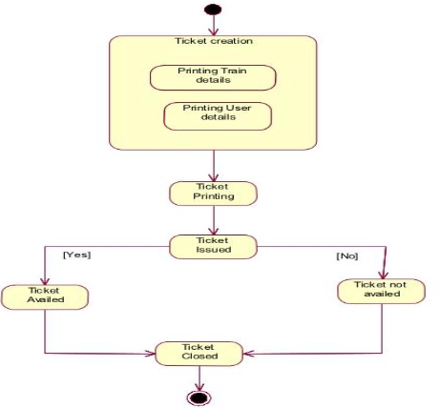

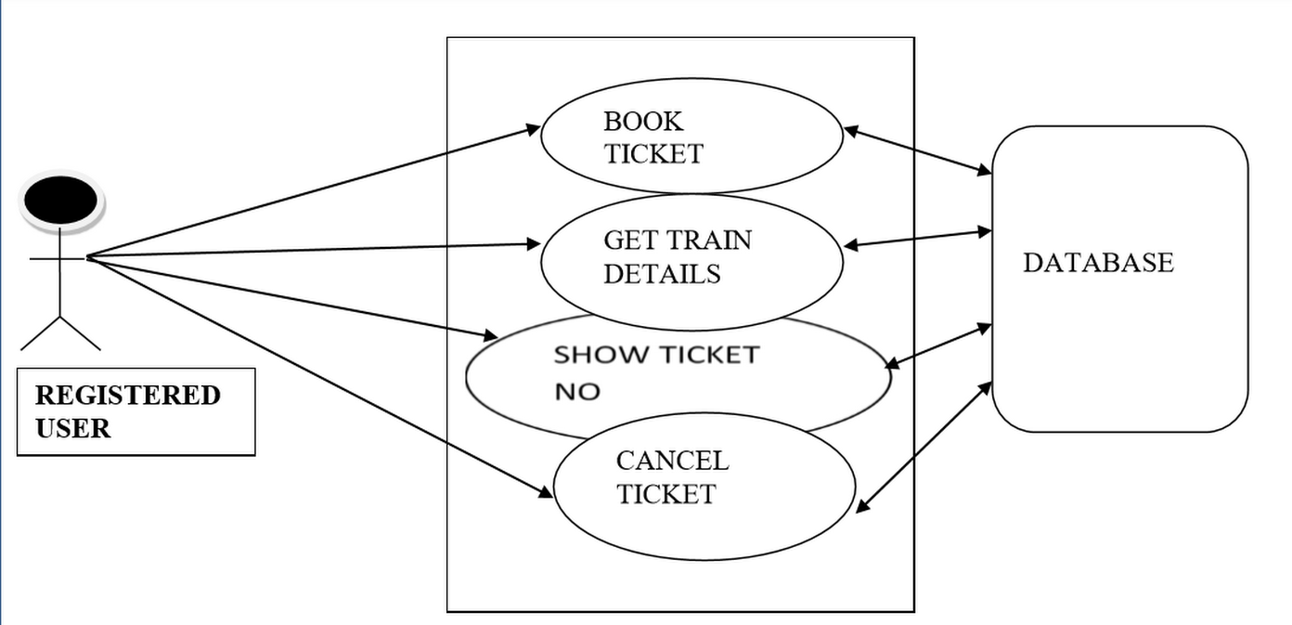

**Results:**

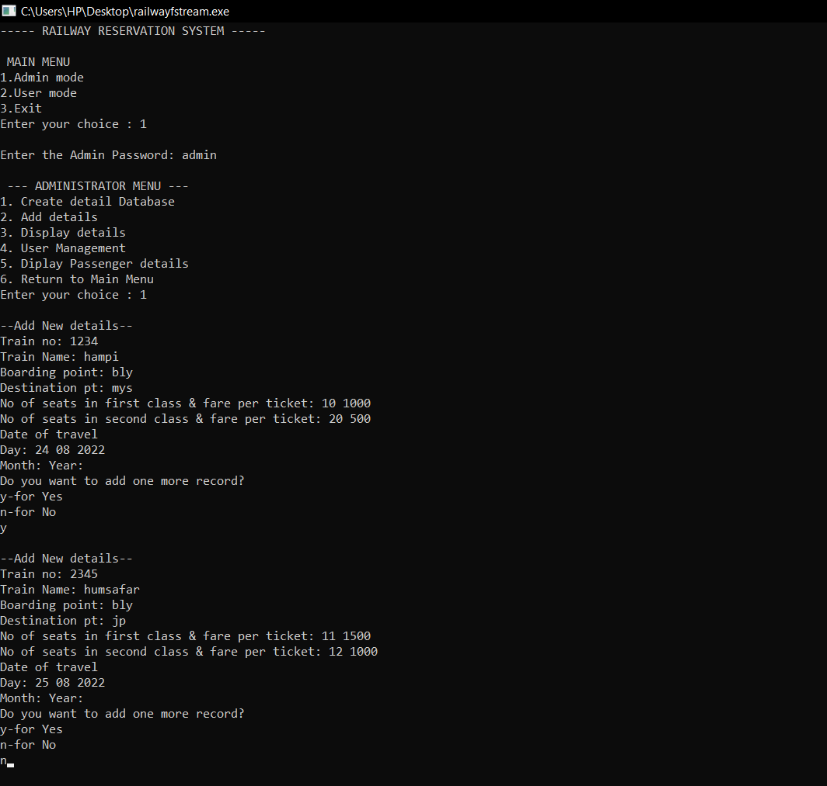

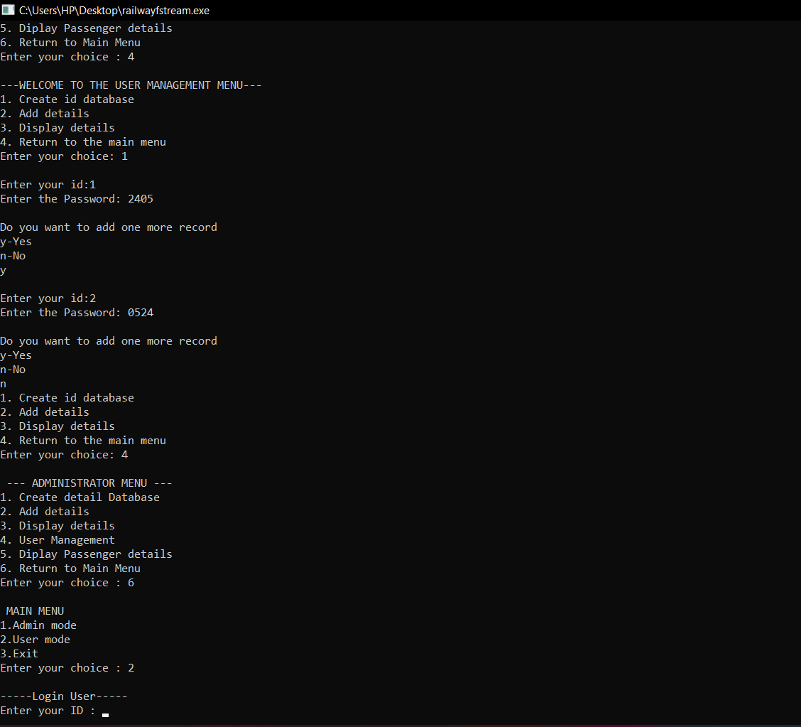

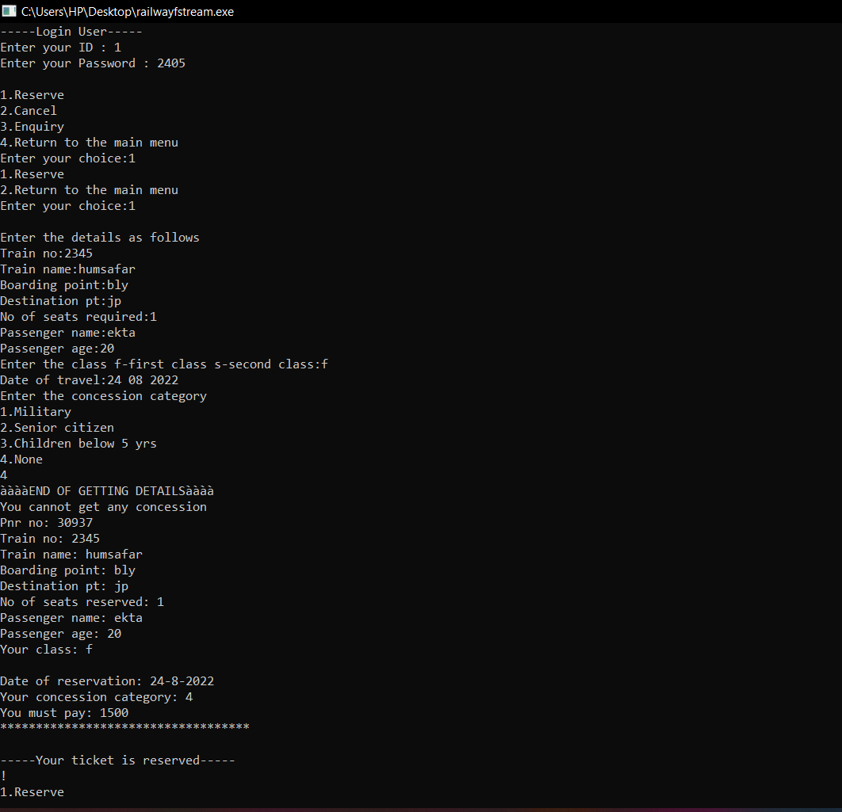

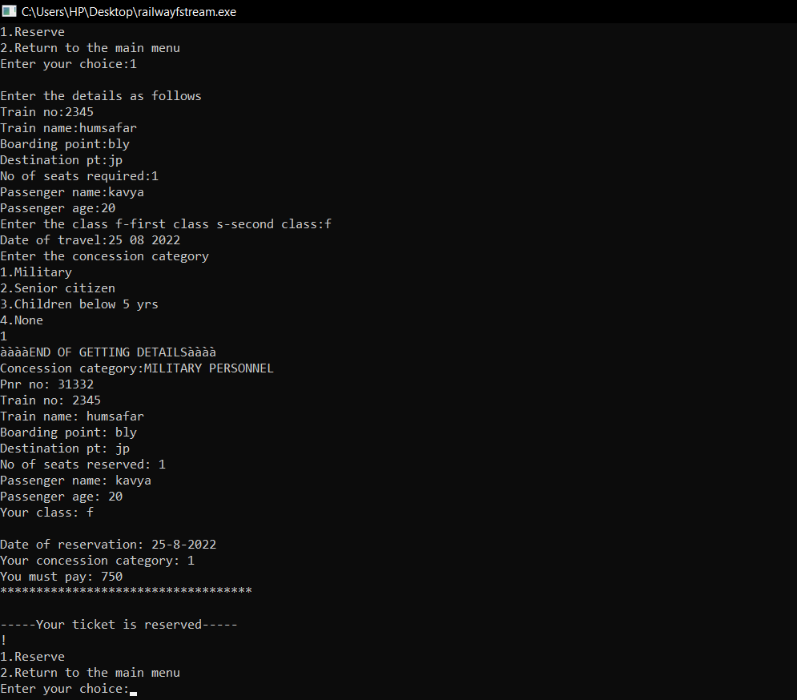

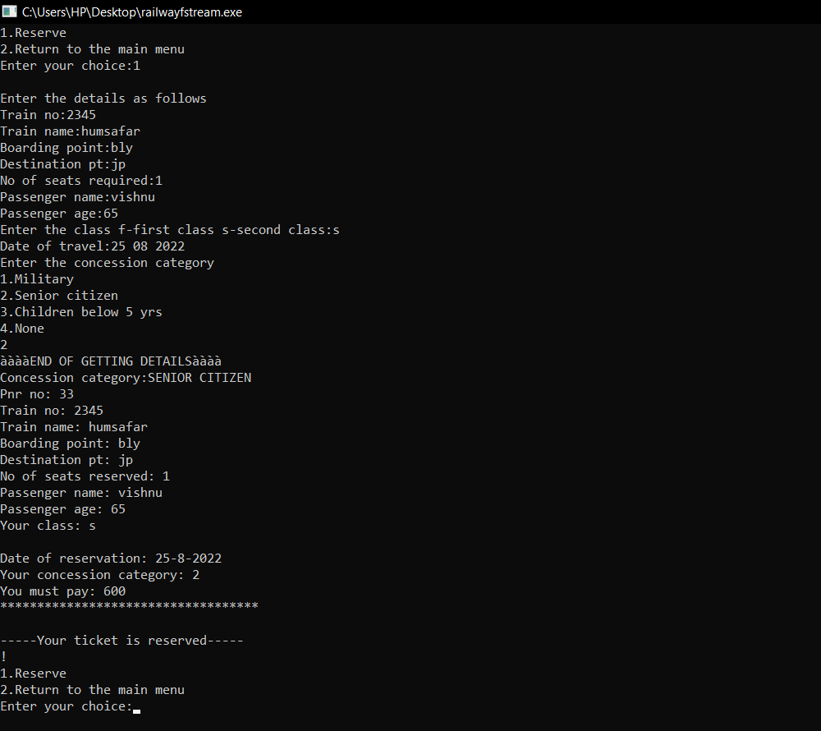

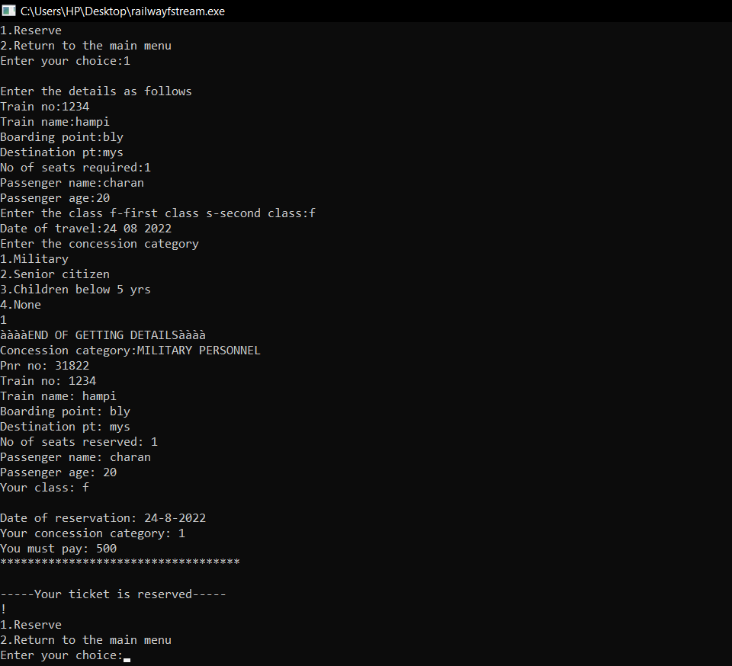

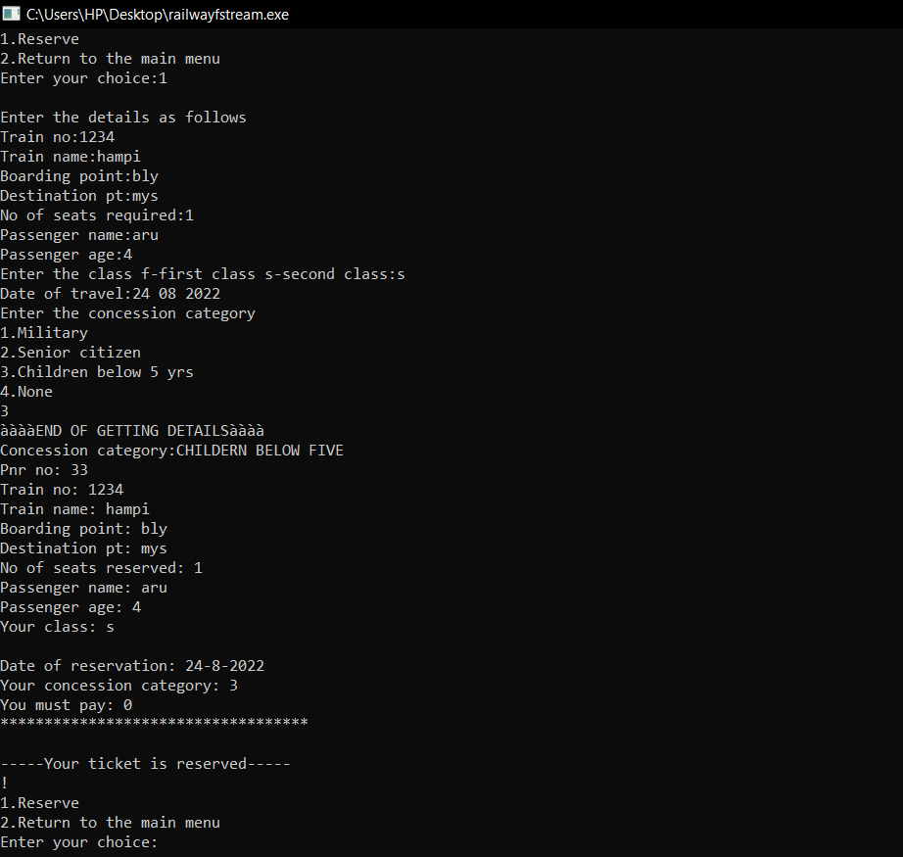

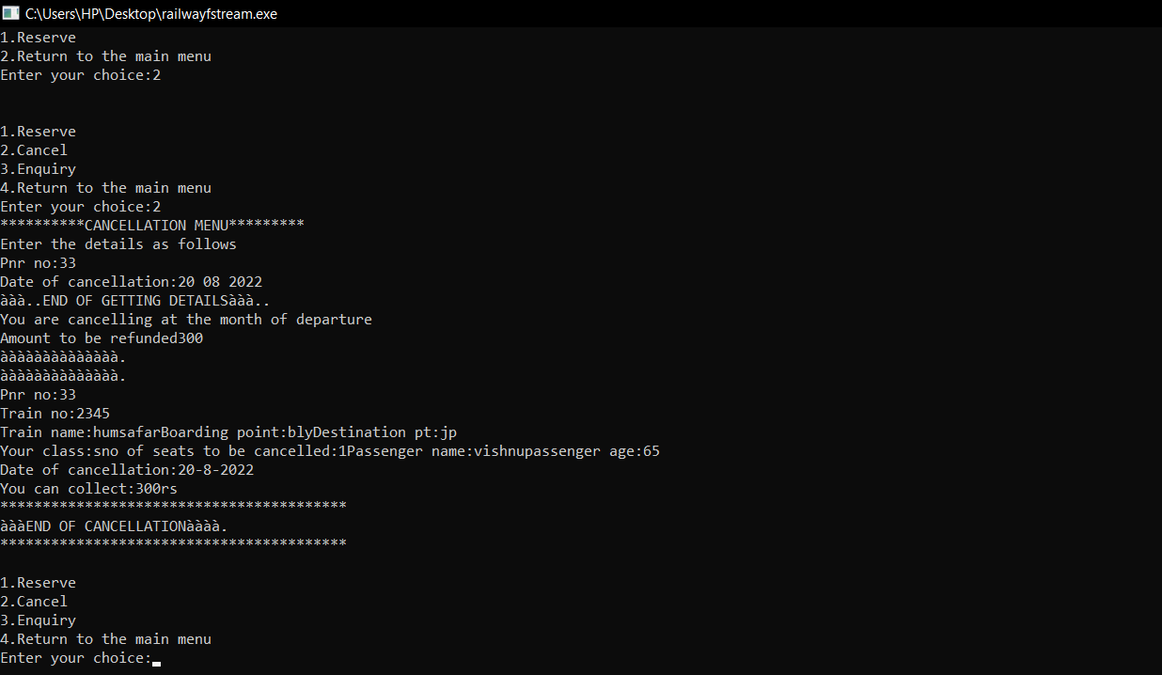

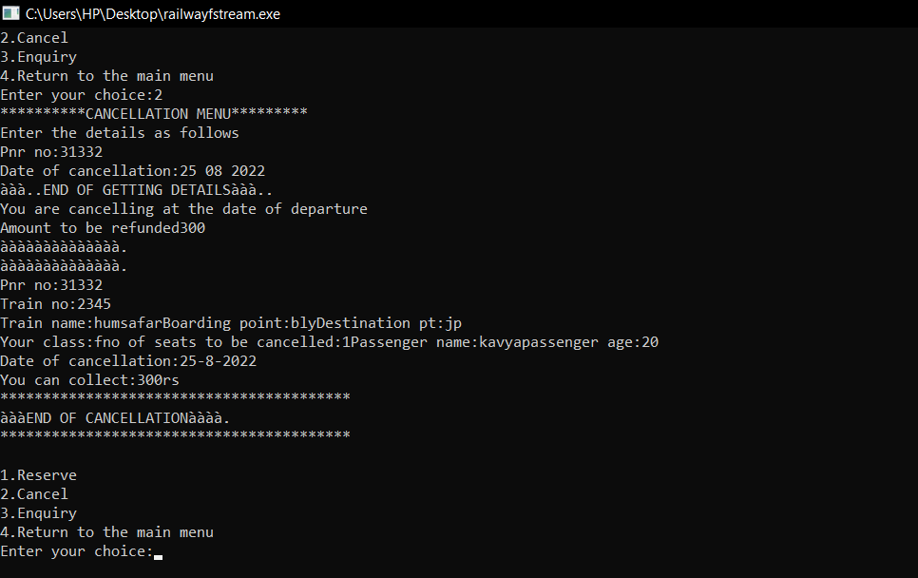

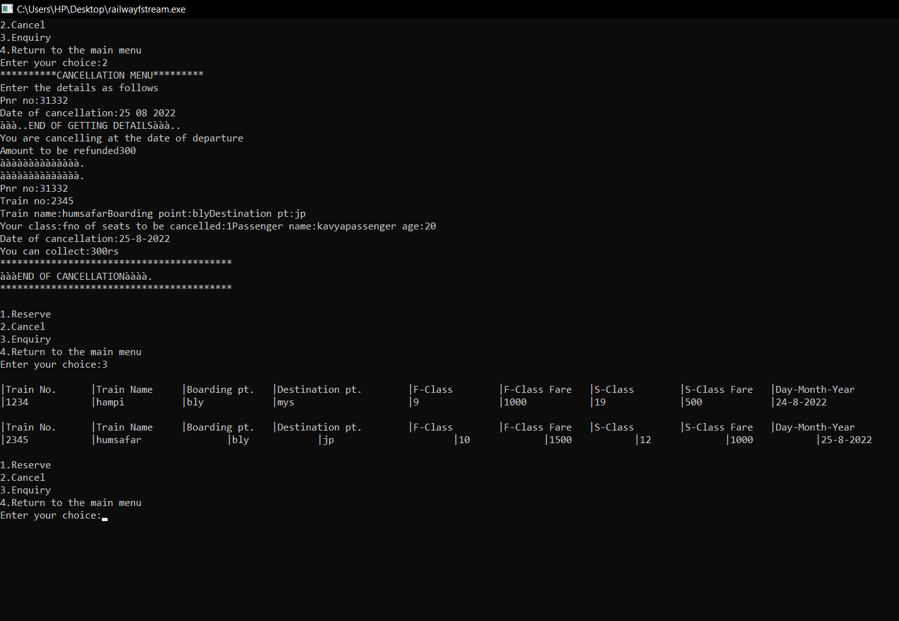

**Conclusion**

The main of developing reservation system is to provide all information that is required by the users. User friendliness is a must that is the user must get the details without complicated searching procedures. Other important requirements of software are data security, extensibility and maintainability.

**REFERENCE**

1. http://www.google.com/

2. http://en.wikipedia.org

***************************************************